(Updated March 31, 2022)

Dear CBINT Family,

We are writing to share with you that CBINT has adopted the following COVID vaccination policy:
All people aged 12 and over must provide proof of vaccination* or a negative PCR Covid test done within 72 hours to attend CBINT indoor services and programming.
- School and youth-only programming are excluded from the vaccination policy.
- All other mitigation policies (mask requirement for ages 2 and above and social distancing) remain in effect.
- This policy will be reviewed every 6 months.

*For CBINT, “proof of vaccination” means fully vaccinated according to the CDC’s current definition. At present, that definition is: 2 weeks (14 days) after your dose of an accepted single-dose vaccine or 2 weeks (14 days) after your second dose of an accepted 2-dose series. Following the CDC, we encourage you to get your COVID booster if you haven’t already.

Our policy decision was carefully considered, informed by medical advisers. It is consistent with the halakhic position of the Conservative Movement that all eligible Jews, adults and children alike, should be vaccinated. We also listened to you – over half of our members responded to a congregation-wide survey on this topic, with 70% indicating that they would feel more comfortable attending services and programs with a vaccine policy in place. Throughout, our deliberations have prioritized creating conditions where our members feel confident to come back into our beautiful building for services and programs. Please know that all services and programs continue to be accessible via Zoom. Unless otherwise indicated, that link is www.tinyurl.com/CBINT-Zoom.

We want to make it as easy as possible for you to provide proof of vaccination, so we are offering these options:
- Email or text a copy of your COVID vaccine card to office@cbintmilwaukee.org. Please put Proof of Vaccination in the subject line.
- Mail a photocopy of your vaccine card to the synagogue office. You may also use the drop-box on the exterior of our building, to the right of the office entrance, at all hours.
- Stop by the office and show your vaccine card to Don Shane, Marlynn Brick, or Anita Nagurka. Please call ahead to make sure one of them will be there to assist you when you arrive.

We will not keep an electronic or physical copy of your card; once we see it, your name will be added to a list so that you are cleared to enter the building for any service or program. If you prefer, you may show your vaccine card in person when you attend a service or program. Alternatively, you may submit proof of a negative COVID test performed by a lab, pharmacy, doctor, or nurse within the 3 days prior to the service or program you plan to attend; a rapid home test will not be accepted.

We are working hard to ensure smooth implementation of this policy, and we will follow up with additional information. Please submit your proof of vaccination as soon as you’re able.

Thank you for your support of this effort and the well-being of our congregational family.
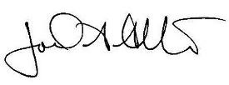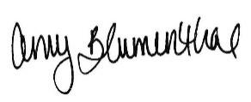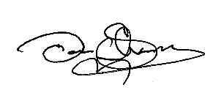
Joel Alter Amy Blumenthal Don Shane
Rabbi President Executive Director

